***Systems Biology***

***Assignment – 3***

*-BS19B032*

*-R. Vasantha Kumar*

***Problem 1:***

*a) Using the transcription network given, I created a network in MATLAB. When, plotted the network will look like:*

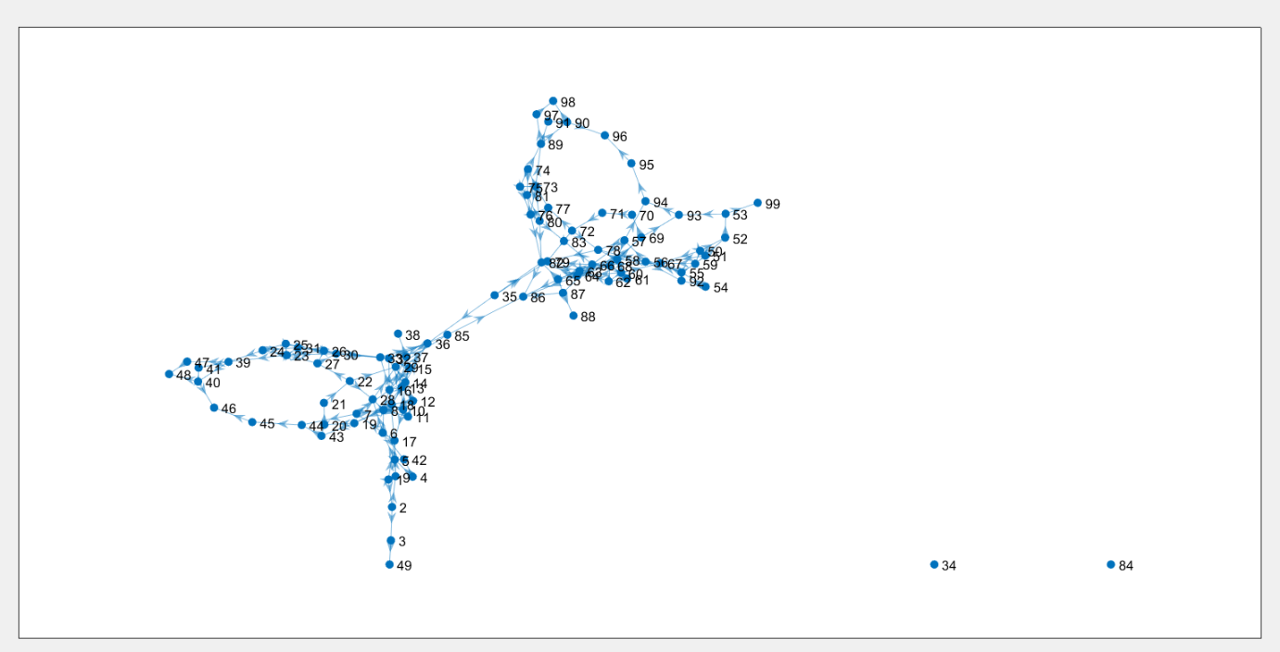

*b)*

***(i) Degree Centrality:***

*The top 5 nodes based on degree centrality are:*

*1) {'18 appY'} - 7*

*2) {'67 csgBA'} - 7*

*3) {'68 csgDEFG'} – 7*

*4) {'82 cytR'} – 7*

*5) {'17 appCBA'} - 6*

***(ii) Closeness Centrality:***

*The top 5 nodes based on closeness centrality are:*

*1) {'17 appCBA'} - Inf*

*2) {'31 argU'} - Inf*

*3) {'34 aroF_tyrA'} - Inf*

*4) {'38 aroP'} - Inf*

*5) {'41 aslB'} - Inf*

***(iii) Betweeness Centrality:***

*The top 5 nodes based on betweeness centrality are:*

1. *{'19 araBAD'} - 173*
2. *{'69 cspA'} - 139*
3. *{'21 araE'} - 107*
4. *{'20 araC'} - 106*
5. *{'22 araFG_araH_1H_2'} - 106*

***(iv) Radiality:***

*The top 5 nodes based on radiality are:*

1. *{'6 ada_alkB'} – 2.7245*
2. *{'5 acs'} – 2.6040*
3. *{'7 adhE'} – 2.5918*
4. *{'8 adiA'} – 2.5918*
5. *{'56 caiF'} – 2.4490*

***(iv) Integration:***

*The top 5 nodes based on integration are:*

1. *{'17 appCBA'} – 0*
2. *{'31 argU'} – 0*
3. *{'34 aroF_tyrA'} – 0*
4. *{'38 aroP'} – 0*
5. *{'41 aslB'} - 0*

*c) To calculate kendall correlation coefficient, I first created a function to find kendall coefficient for two given parameters. Then, using this function, I found the values of kendall coefficients for each pair and recorded it in a 5 by 5 matrix.*

*In this matrix,*

* *Column1 and row1 corresponds to degree centrality*
* *Column2 and row2 corresponds to closeness centrality*
* *Column3 and row3 corresponds to betweeness centrality*
* *Column4 and row4 corresponds to radiality*
* *Column5 and row5 corresponds to integration*

*Therefore, for example, in the matrix, at row2 and column3, there will be kendall correlation value between closeness centrality and betweeness centrality.*

*The final matrix is:*

*1.0000 0.0451 0.1948 -0.0526 0.1177*

*0.0451 1.0000 -0.3247 -0.7856 0.1779*

*0.1948 -0.3247 1.0000 0.3824 -0.2909*

*-0.0526 -0.7856 0.3824 1.0000 -0.0649*

*0.1177 0.1779 -0.2909 -0.0649 1.0000*

*We, can see that for all diagonal elements, the value is 1, as when a centrality matching with itself, is always perfect.*

***Problem 2:***

***a)***

*From the downloaded model of the Staphylococcus aureus iSB619, the maximum growth rates are calculated in the given conditions:*

*(i) Maximum growth rate at 100mmolgDW−1h−1 glucose and aerobic conditions is:*

*0.0277*

*(ii) Maximum growth rate at 100mmolgDW−1h−1 glucose and anaerobic conditions is:*

*0*

*(iii) Maximum growth rate at 100mmolgDW−1h−1 ribose D and aerobic conditions is:*

*0.0243*

*(iv) Maximum growth rate at 100mmolgDW−1h−1 fructose and aerobic conditions is:*

*0.0276*

***b)***

*I analysed the effects of reactions due to the deletion of genes. For carbon reactions, I did not find any genes which has effects upon deletions.*

*So for carbon sources, there are no lethal genes.*